Case 10-A1022-Mex-Tikal Cylinder Vessel-Tripod Legs- ca 350 CE

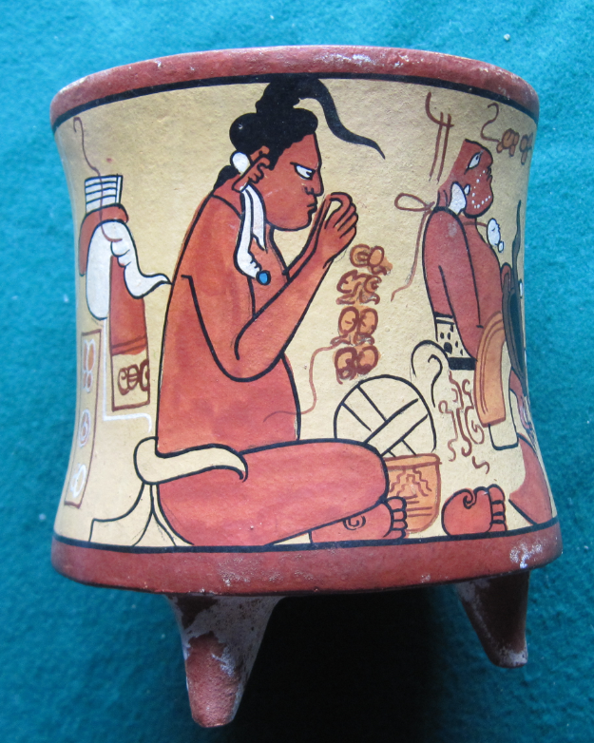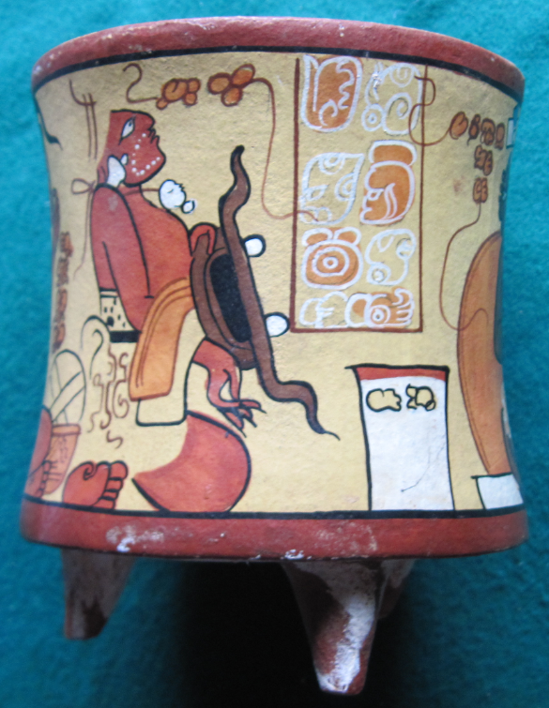

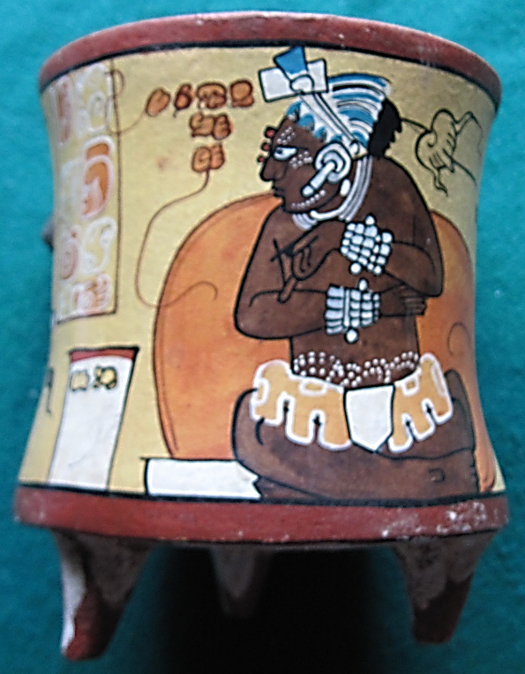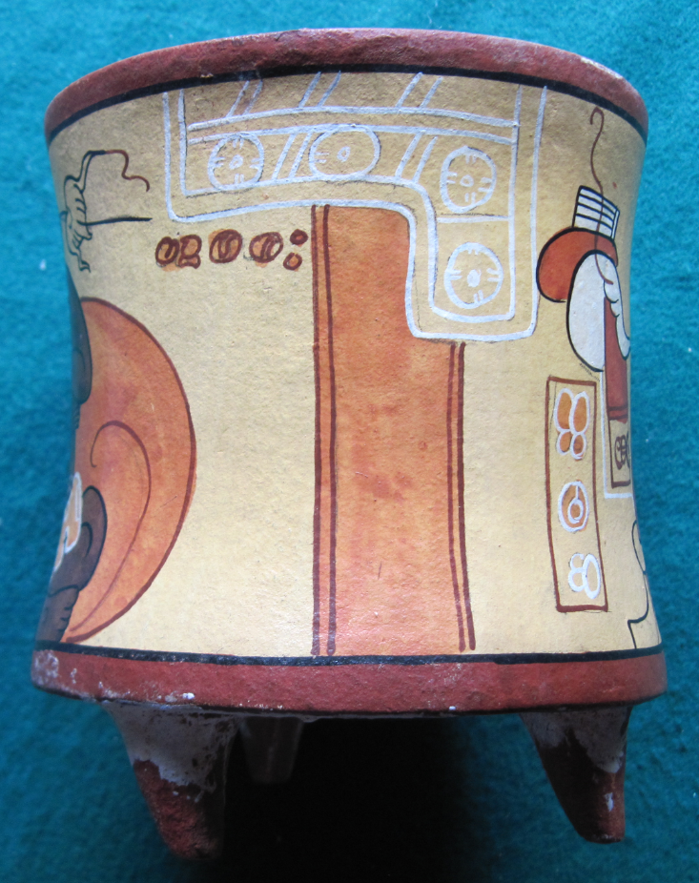

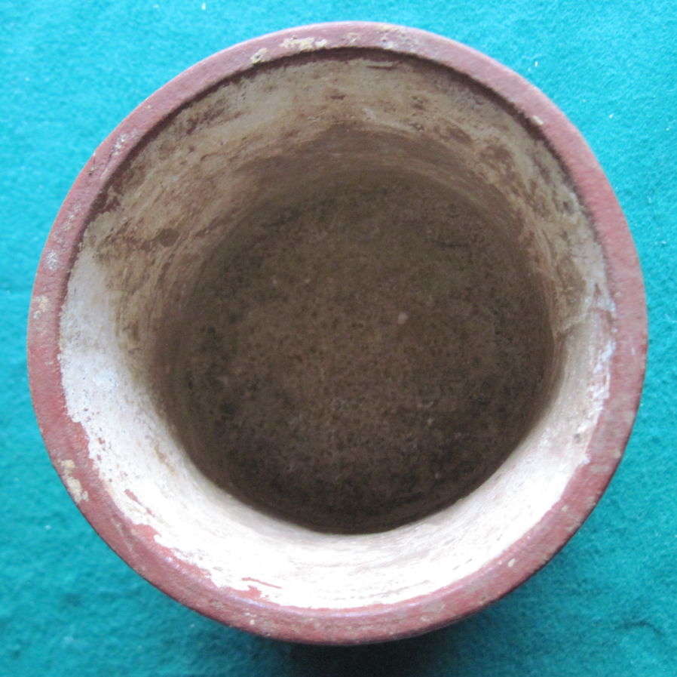 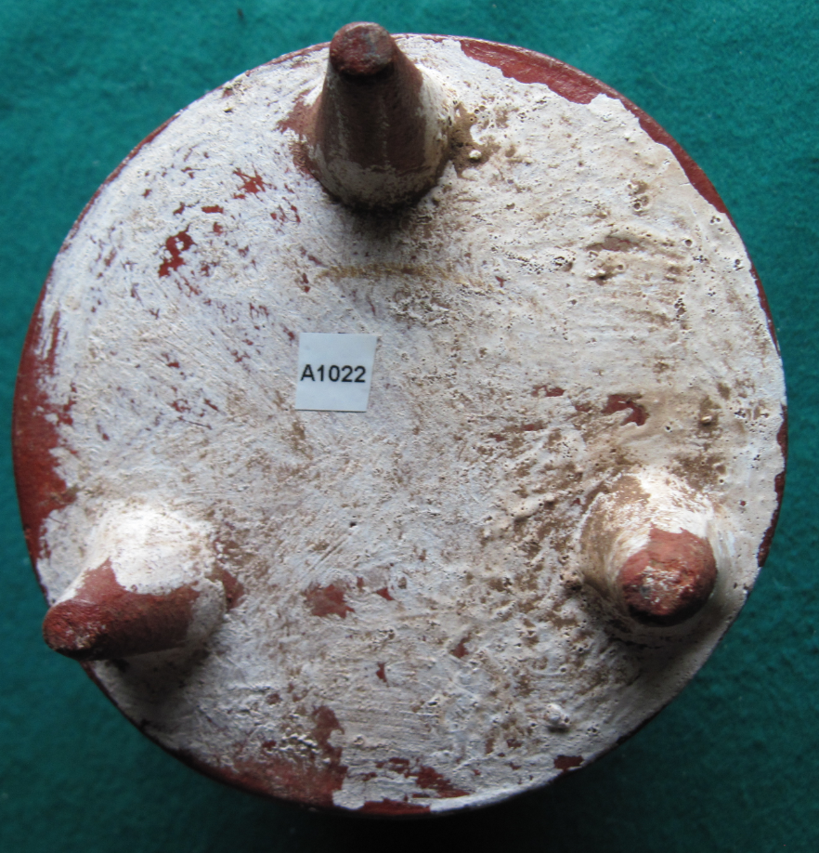

Figs. 1-4. Mex-Tikal Cylinder Vessel-Tripod Legs- ca 350 CE

**Case no.:**

**Accession Number: A 1022**

**Formal Label:** Tikal Cylinder Vessel-Tripod Legs- ca 350 CE

**Display Description:**

Sihyaj K'ahk' (“Fire is Born”) conquered Tikal on January 16, 378 and entered Tikal on 15 May 378, on the death of the previous ruler, Chak Tok Ich'aak I. Then Yax Nuun Ayiin I, a young son of Spearthrower Owl, the powerful king of Teotihuacan, was installed as king of Tikal, in name only and by force. Siyaj K'ak' then led his forces to defeat Uaxactun later that year and immediately established a unification of Tikal and Uaxactun that was to dominate the Guatemalan Petén to 550 CE (Schele and Freidel 1990). Siyaj K'ak' installed new kings at Tikal, Uaxactun, Rio Azul, Waka' (El Peru), El Zapote and Bejucal (Martin and Grube 2000). During this Teotihuacan usurpation of Tikal and Uaxactun, new kings and new rituals and images were introduced by “Fire is Born,” but this cylinder vessel is evidence of the old ways before Sihyaj K'ahk' conquered Tikal and introduced a new courtly ritual at Tikal.

**LC Classification:**

**Date or Time Horizon:** ca 350 CE

**Geographical Area:** Tikal, Peten, Guatemala

**Map, GPS coordinates:** 17.22489 -89.61104,40° 26' 46" N 79° 58' 56" W

**Cultural Affiliation:** lowland Mayan

**Media:** clay, polychrome colors orange, yellow, ochre, blue, kaolin white.

**Dimensions:** H 140.24 mm, 5.32 in; W 120.52 mm, 1.75 in

**Weight: 586 gm, 1 lb 4 5/8 oz**

**Condition: museum reproduction, 1985.**

**Provenance:** Tikal Museum

**Discussion:**

**References:**

Culbert, T. P. 1990. "Polities in the northeast Peten, Guatemala." In *Classic Maya Political History: Hieroglyphic and Archaeological Evidence*, edited by T. P. Culbert. Cambridge: Cambridge University Press.

Evans, Susan Toby and David L Webster, eds. 2013. *Archaeology of Ancient Mexico and Central America: An Encyclopedia*. Hoboken: Taylor and Francis.

Foster, Lynn V. 2006. *Handbook to Life in the Ancient Maya World*. New York: Oxford University Press.

Martin, Simon; Nikolai Grube. 2000. Chronicle of the Maya Kings and Queens: Deciphering the *Dynasties of the Ancient Maya*. London and New York: Thames & Hudson.

Scarborough, Vernon L., Fred Valdez, and Nicholas P Dunning. 2003. *Heterarchy, political economy, and the ancient Maya : the Three Rivers Region of the east-central Yucatán Peninsula*. Tucson: University of Arizona Press.

Schele, Linda; David Freidel. 1990. *A Forest of Kings: The Untold Story of the Ancient Maya.* New York: William Morrow.

Sharer, Robert J.; Loa P. Traxler. 2006. *The Ancient Maya* (6th edition). Stanford: Stanford University Press.

Sullivan, L. A. and K. L. Sagebiel 2003. "Changing Political Alliance in the Three Rivers Region." In *Heterarchy, political economy, and the ancient Maya : the Three Rivers Region of the east-central Yucatán Peninsula*, edited by V. L. Scarborough, F. Valdez, and N. P. Dunning. Tucson: University of Arizona Press.